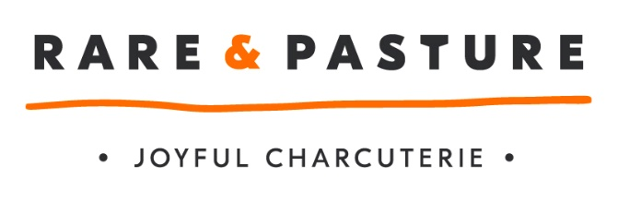

Job Vacancy

Job Title: | Packing Assistant
Name of Employer | Fowlescombe Rare & Pasture Limited
Employer Address: | Fowlescombe Farm  UGBOROUGH  Devon  PL21 0ZG
Number of Vacancies | 2
Contact at Rare & Pasture | Mari or Angie
Phone no.: | n/a
Email: | mari@seabarn.com or angie@rareandpasture.com
Job Overview: | The primary responsibilities of this post are to assist in ensuring that our high standards in products and premises are maintained (quality and hygiene), orders are packed and despatched to customer satisfaction, products are stored correctly, and computerised records are maintained of each process stage. You are part of a small team, so working well with your colleagues, with initiative and efficiency, is also key to the role.  Prime Responsibilities:  - Pack, label and store products in line with food safety procedures to maximise shelf life and product quality  - Liaise with production and sales staff to ensure sufficient but not excessive stock of all products is maintained, and rotate stock in date order  - Maintain upkeep of the department, including stocks of consumables, e.g. packaging, and liaise with managers about purchasing new or replacement items  - Assess products for quality criteria  - Record all processes on computerised stock management/HACCP system  - Comply with the company’s HACCP procedures as specified in the Operations Manual.
Desirable Attributes: | - Food Hygiene Certificate level 2 (manufacturing or catering)  - The ability to plan and organise your workload  - The ability to work well with and learn from others  - Dexterity and an eye for detail  - The ability to work efficiently and in a well-organised manner  - An interest in good quality food that is ethically sourced
Hours to be worked: | 40 hours per week
Salary: | £10.00 PH
Benefits: | Pension, free parking, Monday – Friday day time work, performance bonus, electric bike scheme, staff discounts.
Holiday allowance: | 25 days per year plus bank holidays
Company Info.: | Rare & Pasture is a Devon based award winning British Charcuterie producer. The company’s products are sold all over the UK and for a young business (3 years trading) we have experienced exponential growth.  We make unique in the range of cured, smoked, air dried and cooked charcuterie using Britain’s native and rare breed animals. R&P are committed to making truly crafted delicacies bringing the best of the high quality raw materials that we use.
Website: | www.rareandpasture.com

