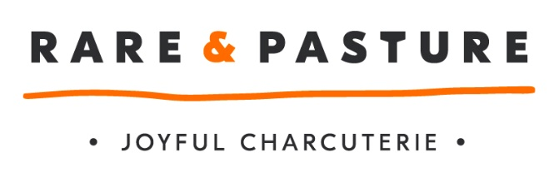

Job Vacancy

Job Title: | Cleaning Operative
Name of Employer | Fowlescombe Rare & Pasture Limited
Employer Address: | Fowlescombe Farm  UGBOROUGH  Devon  PL21 0ZG
Number of Vacancies | 1
Contact at Rare & Pasture | Angie Williams
Phone no.: | n/a
Email: | Angie@rareandpasture.com
Job Overview: | Part time CO’s help with the routine and scheduled cleaning of machinery, equipment, utensils. You will be responsible for carrying out the day to day cleaning and will be responsible to the Production Manager and the Senior Technical Officer.  CO’s train in all aspects of cleaning and will need to develop a good eye for quality, displaying care and diligence in their work. You will also need to be willing to learn and work autonomously under your own initiative.  Prime Responsibilities include:  - Cleaning of machinery and the production unit  - Record and validate the cleaning process
Desirable Attributes: | - Food Hygiene Certificate level 2 (manufacturing or catering)  - The ability to plan and organise your workload  - The ability to work well with and learn from others  - Dexterity and an eye for detail  - The ability to work efficiently and in a well-organised manner  An interest in good quality food that is ethically sourced
Hours to be worked: | 20 per week
Salary: | £9.75 PH
Benefits: | Pension, free parking, Monday – Friday day time work, performance bonus, electric bike scheme, staff discounts.
Holiday allowance: | 25 days per year plus bank holidays
Company Info.: | Rare & Pasture is a Devon based award winning British Charcuterie producer. The company’s products are sold all over the UK and for a young business (3 years trading) we have experienced exponential growth.  We make unique in the range of cured, smoked, air dried and cooked charcuterie using Britain’s native and rare breed animals. R&P are committed to making truly crafted delicacies bringing the best of the high quality raw materials that we use.
Website: | www.rareandpasture.com

